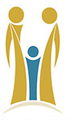 | Islamic Republic of Afghanistan  Afghanistan Central Civil Registration Authority | 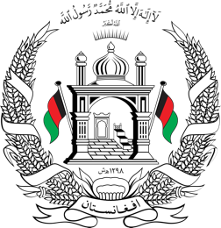
Number: XXXXX
Price: 10 AFN

Province |  |  |  | XXXXX |  |  |  |  | Village |  |  |  |  | XXXXX
District |  |  |  | XXXXX |  |  |  |  | House number
Identification
Name: |  | XXXXX
Father’s name |  | XXXXX
Grand Father’s name |  | XXXXX
Place of birth |  | Country: |  |  |  |  | Province: XXXXX |  |  |  | District:
Date of birth |  | Day: |  |  |  |  | Month: |  |  |  | Year
Age |  | As per archive information, XXXXX years old of XXXXX
Physical Characteristics
Height |  | Medium |  |  |  | Color of hair |  |  |  |  |  | Black
Color of eye |  | Hazel |  |  |  | Color of skin |  |  |  |  |  | Wheaten
Eyebrow |  | Separate |  |  |  | Disability
Color of skin |  | Wheaten
Other sings
Religion |  | Islam |  |  |  | Military Service |  |  |  |  |  | Nomad/ Seasonal Residence
Nationality |  | Afghan |  |  |  | Entry date |  |  |  |  |  | Summer
Occupation |  | Self employed |  |  |  | Releasing date & number |  |  |  |  |  | Winter
Gender |  | Male |  |  |  | Unit |  |  |  |  |  | Tribe
Marital Status |  | Married |  |  |  | Other |  |  |  |  |  | Head of Tribe
Family No. |  |  |  |  |  | Volume No. XXXXX, Page No. XX, Registry No. XX, Previous number: XXXXX
Date |  |  | Day: XXXXX |  |  |  |  |  | Month: XXXXX |  |  |  |  | Year: XXXXX
Month language |  |  | Dari |  |  |  |  |  | Foreign language
Signature of Responsible Officer |  |  |  |  |  |  |  | Signature of Head Officer |  |  |  |  |  |  |  | Signature of Owner
Name | Grade |  |  |  |  |  |  | Name |  | Grade

